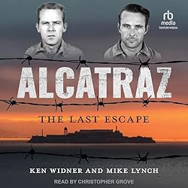

***Alcatraz: The Last Escape*** *b*y Ken Widner (nephew of the Anglin brothers)

We have all traveled out to Alcatraz Island to see the remains of the Federal penitentiary, the remnants of the occupation by American Indians, and to enjoy the overall extraordinary views of the Bay and the Golden Gate Bridge. While touring the prison building, we all have heard the tale of the three prisoners who got off The Rock. What we do not learn is the fate of these three desperate men.

Frank Morris, John Anglin and Clarence Anglin were the three prisoners who escaped from Alcatraz in 1962. Did they really make it?

*Alcatraz: The Last Escape* reveals the hour-by-hour details of their incredibly daring escape. You will read about the long months of planning, their ingenious gathering of supplies and, of course, their mustering of support from other inmates. Did you know there was a fourth prisoner also planning to escape that same night? Allen West’s chipping away at the wall of his cell was incomplete. He was not able to chisel the escape opening large enough to fit his body, so he was left behind. Other prisoners heard him sobbing hysterically late that night.

Did the three get away? Is the photo of the Anglin brothers (living in Brazil) the real deal? Was this famous escape facilitated by gangsters Whitey Bolger or Mickey Cohen? After you read this book, you can come to your own conclusions.

I recommend this book to anyone who enjoys local history and/or a thrilling read.

This is an excellent book for gifting.

Trish Otstott